Number of the Day Instructions:

1. Use a pencil, an eraser, and a piece of paper.

2. Pick a number between 1 and 20.

3. Write down as many ways you can think of to represent that number. Check out the following example:

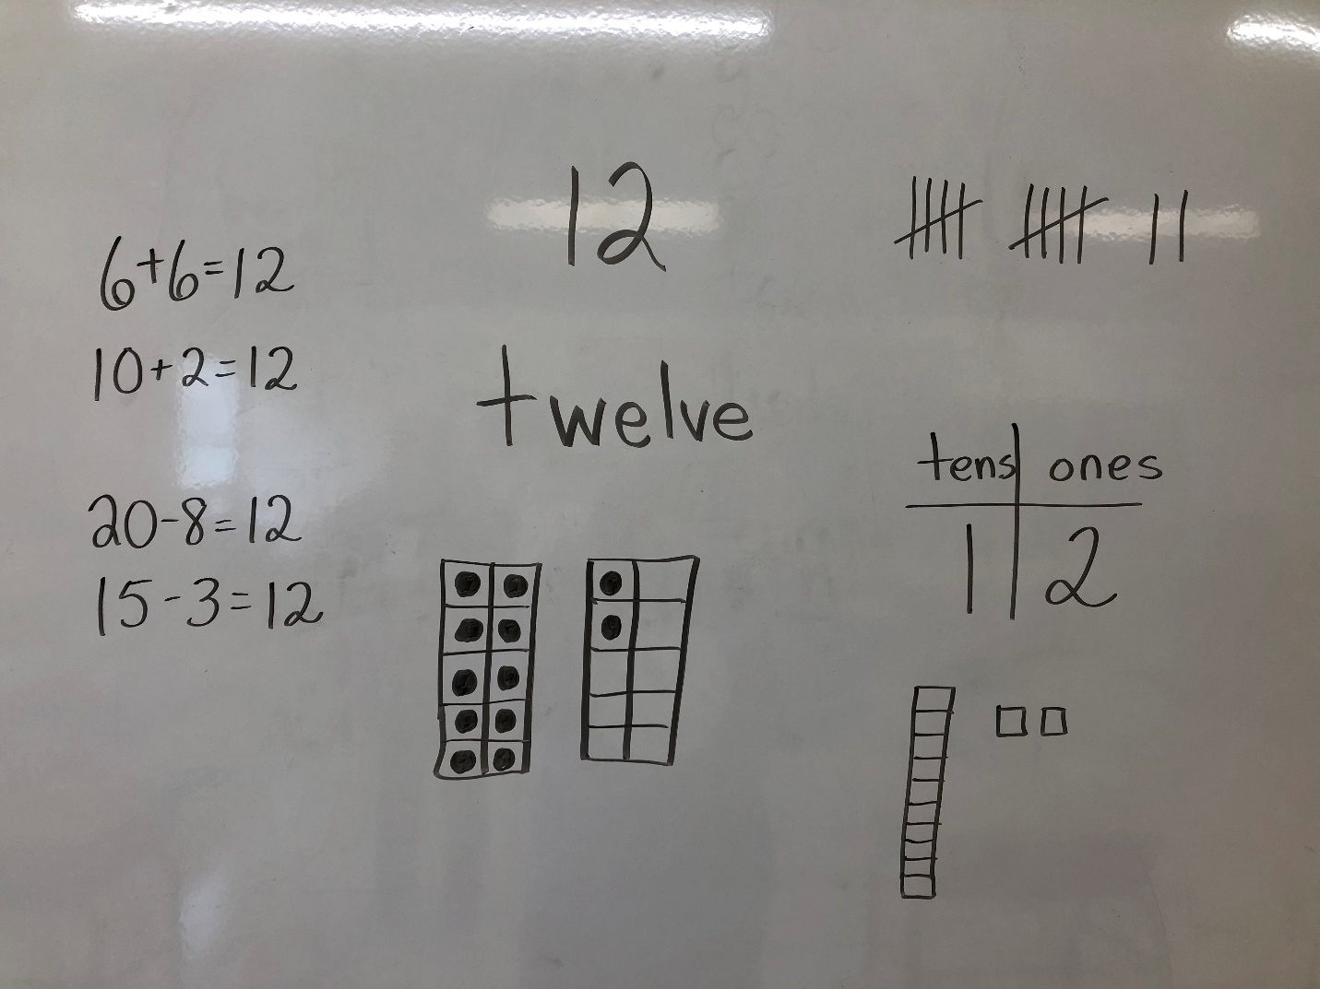

4. If you want to challenge yourself, choose a number greater than 20 and see if you can do it!